LO5 – Using Matrices to Represent Graphic Objects
2-dimensional objects – can be represented as a set of data points, which can be stored in a N×2 matrix (for now), where N is the number of data points.
Three transformations we can do to graphic objects are:
- Scaling: make the object bigger or smaller
- Translation: move the object
- Rotation: rotate the object around some point

Scaling
To scale the object by some factors S_{x} and S_{y},
x’ = x * S_{x}
y’ = y * S_{y}

Translation
To translate the object by some amount T_{x} and T_{y},
x’ = x + T_{x}
y’ = y + T_{y}

Rotation
To rotate clockwise by some angle θ (in radians – recall that
radians = degrees * π / 180)
x’ = x * cos θ + y * sin θ
y’ = -x * sin θ + y * cos θ

Dealing with side effects
We saw that scaling and rotation also moved the object. Rotation or scaling is done around the “world origin” (0, 0). We need to pick a “local origin” to rotate or scale about its own origin. To do so:
- Translate the object to the world origin.
- Scale or rotate the object.
- Translate back to the local origin.
See also “Transformations A.xlsx” or “Transformations B.xlsx” in the LO5 folder of the OneDrive folder for examples of each type of transformation and dealing with side effects.
See also “Local Origin Example MATH282-CST.xlsx” in the LO5 folder for a discussion of choosing the local origin and its effects.

Homogeneous coordinates
To perform transformations on data points using matrices, an additional column of 1’s is added to the data points. So for a 2D set of points, we add a third column of 1’s. This column of 1’s allows us to perform transformations using matrix multiplication. These are called homogeneous coordinates.
Thus the point [x y] is represented as [x y 1].
Example:
$\left[\begin{matrix}1 & 1 \\ 1 & 2 \\ 2 & 3 \\ 3 & 2 \\ 3 & 1\end{matrix}\right]$ would be represented as $\left[\begin{matrix}1 & 1 & 1 \\ 1 & 2 & 1 \\ 2 & 3 & 1 \\ 3 & 2 & 1 \\ 3 & 1 & 1\end{matrix}\right]$

Transformation matrices
We can multiply the data points (represented by homogeneous coordinates) by matrices to perform transformations. The transformation matrices are:
$T\left(a,b\right)=\left[\begin{matrix}1 & 0 & 0 \\ 0 & 1 & 0 \\ T_{x} & T_{y} & 1\end{matrix}\right]$ for translation about by translation factors T_{x} and T_{y}
$S=\left[\begin{matrix}S_{x} & 0 & 0 \\ 0 & S_{y} & 0 \\ 0 & 0 & 1\end{matrix}\right]$ for scaling by factors S_{x} and S_{y}
$R=\left[\begin{matrix}cosθ & -sinθ & 0 \\ sinθ & cosθ & 0 \\ 0 & 0 & 1\end{matrix}\right]$ for rotation by a clockwise angle θ in radians

Simple example
Suppose we have the points (1, 1) and (2, 2) and we want to translate by T_{x} = 2 and T_{y} = -1.
$$\left[\begin{matrix}1 & 1 & 1 \\ 2 & 2 & 1\end{matrix}\right]*\left[\begin{matrix}1 & 0 & 0 \\ 0 & 1 & 0 \\ 2 & -1 & 1\end{matrix}\right]=\left[\begin{matrix}3 & 0 & 1 \\ 4 & 1 & 1\end{matrix}\right]$$
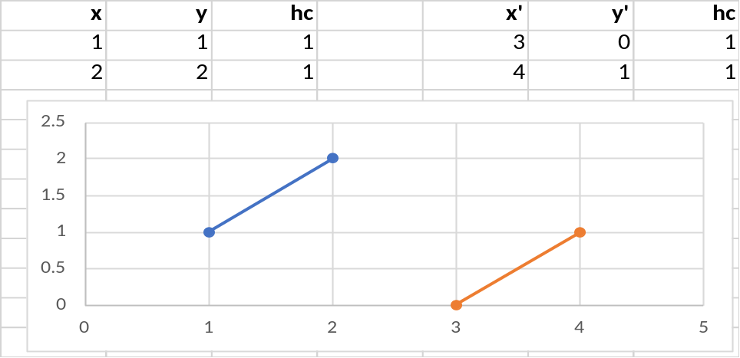
We see that the line is moved to the right by 2 and down by 1.

Dealing with side effects
Recall that scaling and rotation had the side effect of moving the object. To counter that side effect, we translate the object from the local origin to the world origin, then do scaling or rotation, and then translate back.
To do so with matrices, we multiply by 3 matrices:
Scaling: points * T(-a,-b) * S * T(a,b) for a local origin (a, b)
Rotation: points * T(-a,-b) * R * T(a,b) for a local origin (a, b)

Example
We want to translate our house data points (from the example above) by rotating it 180 degrees around the local origin (2, 3). Then we have the following (note that cos(180 deg) = -1 and sin(180 deg) = 0):
$$\left[\begin{matrix}1 & 1 & 1 \\ 1 & 2 & 1 \\ 2 & 3 & 1 \\ 3 & 2 & 1 \\ 3 & 1 & 1\end{matrix}\right]*\left[\begin{matrix}1 & 0 & 0 \\ 0 & 1 & 0 \\ -2 & -3 & 1\end{matrix}\right]*\left[\begin{matrix}-1 & 0 & 0 \\ 0 & -1 & 0 \\ 0 & 0 & 1\end{matrix}\right]*\left[\begin{matrix}1 & 0 & 0 \\ 0 & 1 & 0 \\ 2 & 3 & 1\end{matrix}\right]$$
$$=\left[\begin{matrix}-1 & -2 & 1 \\ -1 & -1 & 1 \\ 0 & 0 & 1 \\ 1 & -1 & 1 \\ 1 & -2 & 1\end{matrix}\right]*\left[\begin{matrix}-1 & 0 & 0 \\ 0 & -1 & 0 \\ 0 & 0 & 1\end{matrix}\right]*\left[\begin{matrix}1 & 0 & 0 \\ 0 & 1 & 0 \\ 2 & 3 & 1\end{matrix}\right]$$
$$=\left[\begin{matrix}1 & 2 & 1 \\ 1 & 1 & 1 \\ 0 & 0 & 1 \\ -1 & 1 & 1 \\ -1 & 2 & 1\end{matrix}\right]*\left[\begin{matrix}1 & 0 & 0 \\ 0 & 1 & 0 \\ 2 & 3 & 1\end{matrix}\right]$$
$$=\left[\begin{matrix}3 & 5 & 1 \\ 3 & 4 & 1 \\ 2 & 3 & 1 \\ 1 & 4 & 1 \\ 1 & 5 & 1\end{matrix}\right]$$
Note how the local origin (2, 3) moves to the world origin (0, 0) and back again during the transformations.
See the MultiplyingOneMatrixAtATime worksheet in “Rotate Around Local Origin With Matrices.xlsx” in the LO5 folder of the MATH 282 OneDrive folder to visualize these transformations.

Reducing the work
To rotate or scale without side effects, we had to multiply by three matrices. How can we reduce the work? Let’s examine rotation, where we know we have to do points * T(-a,-b) * R * T(a,b)
$$\left[\begin{matrix}x' & y' & 1\end{matrix}\right]=\left[\begin{matrix}x & y & 1\end{matrix}\right]\left[\begin{matrix}1 & 0 & 0 \\ 0 & 1 & 0 \\ -T_{x} & -T_{y} & 1\end{matrix}\right]\left[\begin{matrix}cosθ & -sinθ & 0 \\ sinθ & cosθ & 0 \\ 0 & 0 & 1\end{matrix}\right]\left[\begin{matrix}1 & 0 & 0 \\ 0 & 1 & 0 \\ T_{x} & T_{y} & 1\end{matrix}\right]$$
$$=\left[\begin{matrix}x & y & 1\end{matrix}\right]\left[\begin{matrix}cosθ & -sinθ & 0 \\ sinθ & cosθ & 0 \\ -T_{x}cosθ-T_{y}sinθ & T_{x}sinθ-T_{y}cosθ & 1\end{matrix}\right]\left[\begin{matrix}1 & 0 & 0 \\ 0 & 1 & 0 \\ T_{x} & T_{y} & 1\end{matrix}\right]$$
$$=\left[\begin{matrix}x & y & 1\end{matrix}\right]\left[\begin{matrix}cosθ & -sinθ & 0 \\ sinθ & cosθ & 0 \\ -T_{x}cosθ-T_{y}sinθ+T_{x} & T_{x}sinθ-T_{y}cosθ+T_{y} & 1\end{matrix}\right]$$
So now we have a single combined rotation matrix that we can multiply against data points.
See the UsingCombinedRotationMatrix worksheet and the Rocket worksheet in “Rotate Around Local Origin With Matrices.xlsx” for examples of using this single combined matrix.
See also “2021 Rotation About a PointA.xlsx” or “2021 Rotation About a PointB.xlsx” and “Rotation Around a Point example.xlsx”.
We did the combined rotation matrix. You should consider how to reduce the work for scaling. Recall that:
result = points * T(-a,-b) * S * T(a,b) for a local origin (a, b)

